Week 9 Work Log: Open-Source Software Licences

Complete this worksheet as a team during or after the Week 9 workshop. Add more rows if needed.

Group | Forecasting 4 | Workshop | Thursday 3:30pm – 5:30pm
Project title | Forecasting Model Development: AI-Powered Energy Prediction | Date | 08/10/2026
Client | ARC Research Hub for Integrated Energy Storage Solutions | Members present | Yaqiao, Bhumika, Vidhi, Marwa

  - Activity 1 Selecting and justifying a licence
Identify the licences of the components you actually depend on, then choose one for your own project. A licence is a decision with consequences, not a box to tick - the right choice depends on whether you want your work reused freely, kept open, or protected from commercial lock-in. Use the EU JLA find-and-compare tool to check your options.

Component / dependency | Its licence | Licence family | What it requires you to do
pandas | BSD 3-Clause | Permissive | Keep copyright, licence and disclaimer when redistributing.
NumPy | BSD 3-Clause | Permissive | Retain licence and copyright notices.
scikit-learn | BSD 3-Clause | Permissive | Retain licence and copyright notices.
TensorFlow / Keras | Apache 2.0 | Permissive | Include licence and required notices when distributing.
XGBoost | Apache 2.0 | Permissive | Include licence, notices and indicate modified files where applicable.
SHAP | MIT | Permissive | Include copyright and licence notice in copies.
LIME | BSD 2-Clause | Permissive | Retain copyright and disclaimer notices.
Matplotlib | Matplotlib licence (PSF-based) | Permissive | Review and retain its applicable licence notices.
PJM hourly dataset (Kaggle) | CC0 1.0 Universal (confirmed on Kaggle Data Card) | Public-domain dedication | No copyright attribution is required under CC0; cite Kaggle and PJM for academic transparency.

Note: our project only imports and calls these libraries; we do not modify or redistribute their source code. The obligations above therefore apply only if their code is redistributed. All dependencies and their licences are listed in the project README.
Evidence: screenshots of each LICENSE file, the CC0 licence and the Kaggle dataset page are included in the Appendix – Licence Evidence below, together with the Licensing Assistant comparison.

Licence chosen for your project, and why it fits | We chose the MIT Licence. All of our dependencies use permissive licences (BSD, Apache 2.0 and MIT) and the dataset is CC0, so MIT creates no compatibility conflicts. The project is a research prototype for the ARC Research Hub, and MIT allows the client, researchers and industry partners to reuse and adapt the code with only one condition: keeping the copyright and licence notice.  Apache 2.0 adds an explicit patent grant but is longer and requires change notices;  GPL-3.0 would require all derived work to remain open source, which could discourage industry partners from building it. Since our priority is easy reuse and the project contains no patentable invention, MIT is the best fit.
Does it adhere to the open-source principles (free redistribution, source availability)? How? | Yes. MIT is an OSI-approved licence. It allows anyone to use, copy, modify, merge, publish, distribute, sublicense and sell copies of the software, with no restrictions on who can use it or for what purpose (free redistribution). The full source code, including the Colab notebook, will be publicly available in our GitHub repository together with a LICENSE file (source availability).
How the licence choice could affect community engagement and reuse | MIT lowers the barrier to reuse, so researchers, students and industry partners can easily adopt or extend our forecasting pipeline and combine it with other permissively licensed code.  The trade-off is that others can use our code in closed-source products and are not required to share their improvements, so community contributions depend on goodwill rather than obligation.  To encourage engagement, we will provide a clear README, a requirements.txt file and a well-documented notebook.

  - Activity 2 Modifications, compatibility and contribution
Licences govern what happens when you change code and combine it. Map the modifications your project will make against what each licence allows, then plan a contribution back to an open-source project - forking, changing, and submitting a pull request is a deliverable, not just reading.

Planned modification / integration | Licence(s) involved | What the licence requires here | Compatible? (Y/N)
Import and call pandas, NumPy, scikit-learn, XGBoost, TensorFlow/Keras, SHAP, LIME and Matplotlib in our notebook, without modifying their source code | BSD 3-Clause, BSD 2-Clause, Apache 2.0, MIT, Matplotlib licence | Using a library requires no action. Obligations apply only if we redistribute their code. We will list each dependency and its licence in the README and requirements.txt. | Y
Store the cleaned PJM dataset in our GitHub repository so the notebook can load it in any Colab session (Jira IF4T-85) | CC0 1.0 | CC0 waives all rights, so redistribution is allowed without conditions. We will still cite Kaggle and PJM as the source. | Y
Publish trained model files and results (lstm_model.keras, model_comparison_results.csv) in the repository | MIT (our own work), derived from CC0) data | Our own outputs are covered by our MIT licence. CC0 places no restrictions on work derived from the data. | Y
Release our own notebook and code under the MIT Licence | MIT, together with all of the above | MIT is compatible with BSD, Apache 2.0 and CC0. We will add a LICENSE file with our copyright notice. Since we do not bundle any Apache-licensed code, no NOTICE file is needed. | Y

Open-source contribution plan

Project / repository you will contribute to, and the task you chose | shap/shap - fixed two typos (“interpet” -> “interpret”, “highights” -> “highlights”) in the official tutorial notebook An introduction to explainable AI with Shapley values (notebooks/overviews/). We chose SHAP because our project uses it for model interpretability, and we had read this tutorial when applying SHAP to our XGBoost and LSTM models. A documentation fix is a small, self-contained change suitable for a first contribution, and the tutorial itself invites readers to submit pull requests to improve it.
Steps: fork, change, pull request (link the PR when submitted) | 1. Read SHAP’s CONTRIBUTING guide. It states that trivial typo fixes do not need an issue first, that PR titles should use a prefix such as “DOCS:”, and that any AI assistance must be disclosed. We also checked that recent pull requests were being reviewed and merged.  2. Searched the repository for typos and confirmed that no open pull request already fixed them.  3. Forked shap / shap to the Yaqiao-chi-helen account.  4. Created the branch doc/fix-intro-notebook-typos and edited the notebook in github.dev (the browser version of VS Code), using the plain-text editor so that only the two words changed. We checked the diff ( +2 -2) before committing.  5. Committed with the message “DOCS: fix two typos in intro to explainable AI notebook” and opened a pull request to shap/shap:main using the repository’s PR template, including an AI-usage disclosure.  PR link: https://github.com/shap/shap/pull/5225 – Status: submitted 15 Oct 2026, open and awaiting maintainer review.
Challenges encountered, and how you overcame them | - Finding a suitable task: pandas’ “good first issue” tasks were claimed very quickly, and SHAP’s good first issues were mostly older, larger tasks with long discussion threads. Searching for common misspellings (e.g. “recieve”) returned no results because SHAP’s Python code and .rst docs had already been cleaned. We instead scanned the repository with a spell-checking tool and found the remaining typos were in tutorial notebooks.  - Understanding the guidelines: the CONTRIBUTING guide is long and mostly covers local development setup. We identified the parts relevant to a documentation fix: no issue needed, the “DOCS:” title prefix, a descriptive branch name and the AI usage policy.  - Large file could not be edited in the browser: the notebook is about 2.8MB, and GitHub’s standard web editor loaded it as an empty file. Committing it would have deleted the whole tutorial. We switched to github.dev, opened the notebook as plain text to avoid reformatting the JSON, and checked the diff before committing.  - Review time: many typo-fix PRs in SHAP are still waiting for review, and CI checks for first-time contributors need maintainer approval before they run. Merging is outside our control, so we will monitor the PR and respond to any feedback.

Contribution register

Every member completes at least one row in their own words. Mark each task M for management (planning, client contact, minutes, scheduling, risk, document control) or T for technical (research, requirements drafting, design, prototyping, testing, tooling). Evidence must be something the tutor can open; rows without evidence do not count.

Member name | Task / activity completed this week | Type (M / T) | Evidence (link, file, commit, minutes) | Time spent (hrs)
Yaqiao Chi | 1. Met with all four members on 8 Oct: presented project status and assigned testing and documentation tasks in Jira with deadlines; sent written step-by-step task instructions to the group.  2. Researched the licences of all project dependencies and the PJM dataset (CC0), compared MIT, Apache-2.0 and GPL-3.0 using the EU Licensing Assistant, selected the MIT Licence and completed Activity 1 and 2.  3. Made an open-source contribution: forked shap/shap, fixed two typos in the official SHAP tutorial notebook and submitted pull request #5225 (https://github.com/shap/shap/pull/5225) , open and awaiting review.  4. Found and fixed two notebook defects during regression testing: (a) “Run all” failed because a function was used before it was defined, fixed by correcting the cell order; (b) LSTM results varied between runs (217.78 vs 256.67 MW), fixed by enabling fixed seeds and deterministic GPU operations. Two consecutive runs then gave identical results.  5. Re-ran the full pipeline and updated all results and documentation with the final reproducible numbers: LSTM MAE 237.83 MW; Hybrid MAE 228.96 MW (MAPE 0.728%).  6. Changed the notebook to load the dataset from the public GitHub repository (IF4T-85) and removed the unused Google Drive mount, so the notebook runs end-to-end in a fresh Colab session;  7. Wrote the plain-English summary for non-technical readers (IF4T-89) and sent it for usability testing.  8. Added automated data quality checks to the notebook (IF4T-81). | M & T | Jira board: https://ict30016.atlassian.net/jira/software/projects/IF4T/boards/3/backlog  GitHub notebook (newest version): https://github.com/Yaqiao-chi-helen/Forecasting-team4/blob/main/notebooks/Model_XGBoost_LSTM_latest_one.ipynb  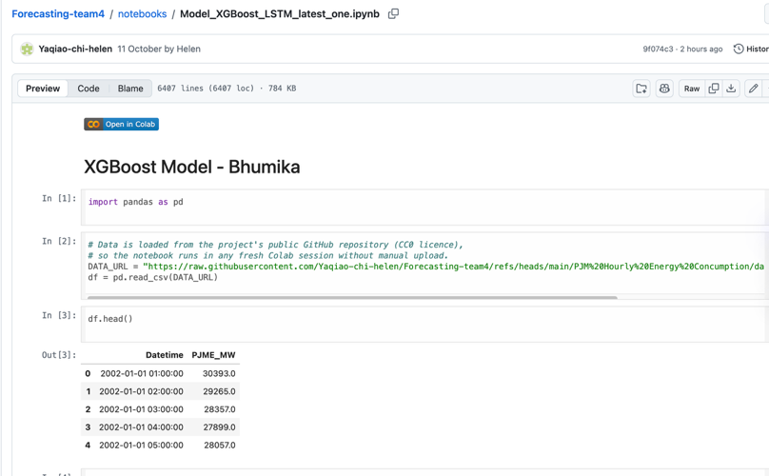 | 17.5 h
Bhumika Sharma | Worked on the AI-powered energy forecasting project by reviewing the model evaluation process and identifying areas requiring further validation.  Planned a lag feature leakage spot-check (IF4T-82) to verify that forecasting features use only information available at prediction time.  Planned a forecasting error analysis (IF4T-88) to compare model performance across seasons, weekdays and peak periods, and identify the five days with the largest prediction errors. | M & T
Vidhi Patel | Attended the Week 9 workshop (8 Oct) was briefed on project progress and took on the testing tasks IF4T-86 and IF4T-90.  Completed a fresh Colab end-to-end reproducibility test of Model_XGBoost_LSTM_latest_one.ipynb (IF4T-86) on a T4 GPU. Result: PASS. The notebook ran without errors and reproduced all reported results exactly (XGBoost MAE 335.78 MW, LSTM 237.83 MW, Hybrid 228.96 MW; LSTM training 5.6 min).  Logged 5 reproducibility issues with recommendations: three notebook versions in the repo, undocumented GPU requirement, out-of-order saved outputs, an unneeded Google Drive mount, and leftover cells.  Usability test of the plain-English summary (IF4T-90) planned for 13 Oct. | T | My test run: https://colab.research.google.com/drive/1S4laW3qer5o3ZnalwJp_E05r617vLCYy?usp=sharing  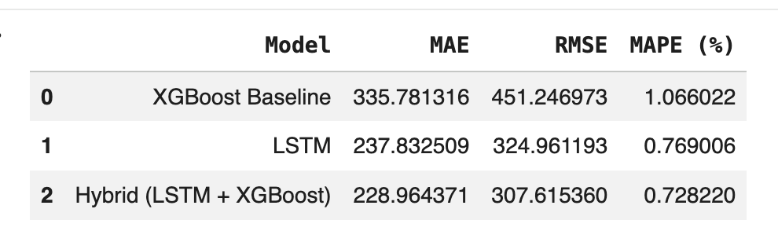  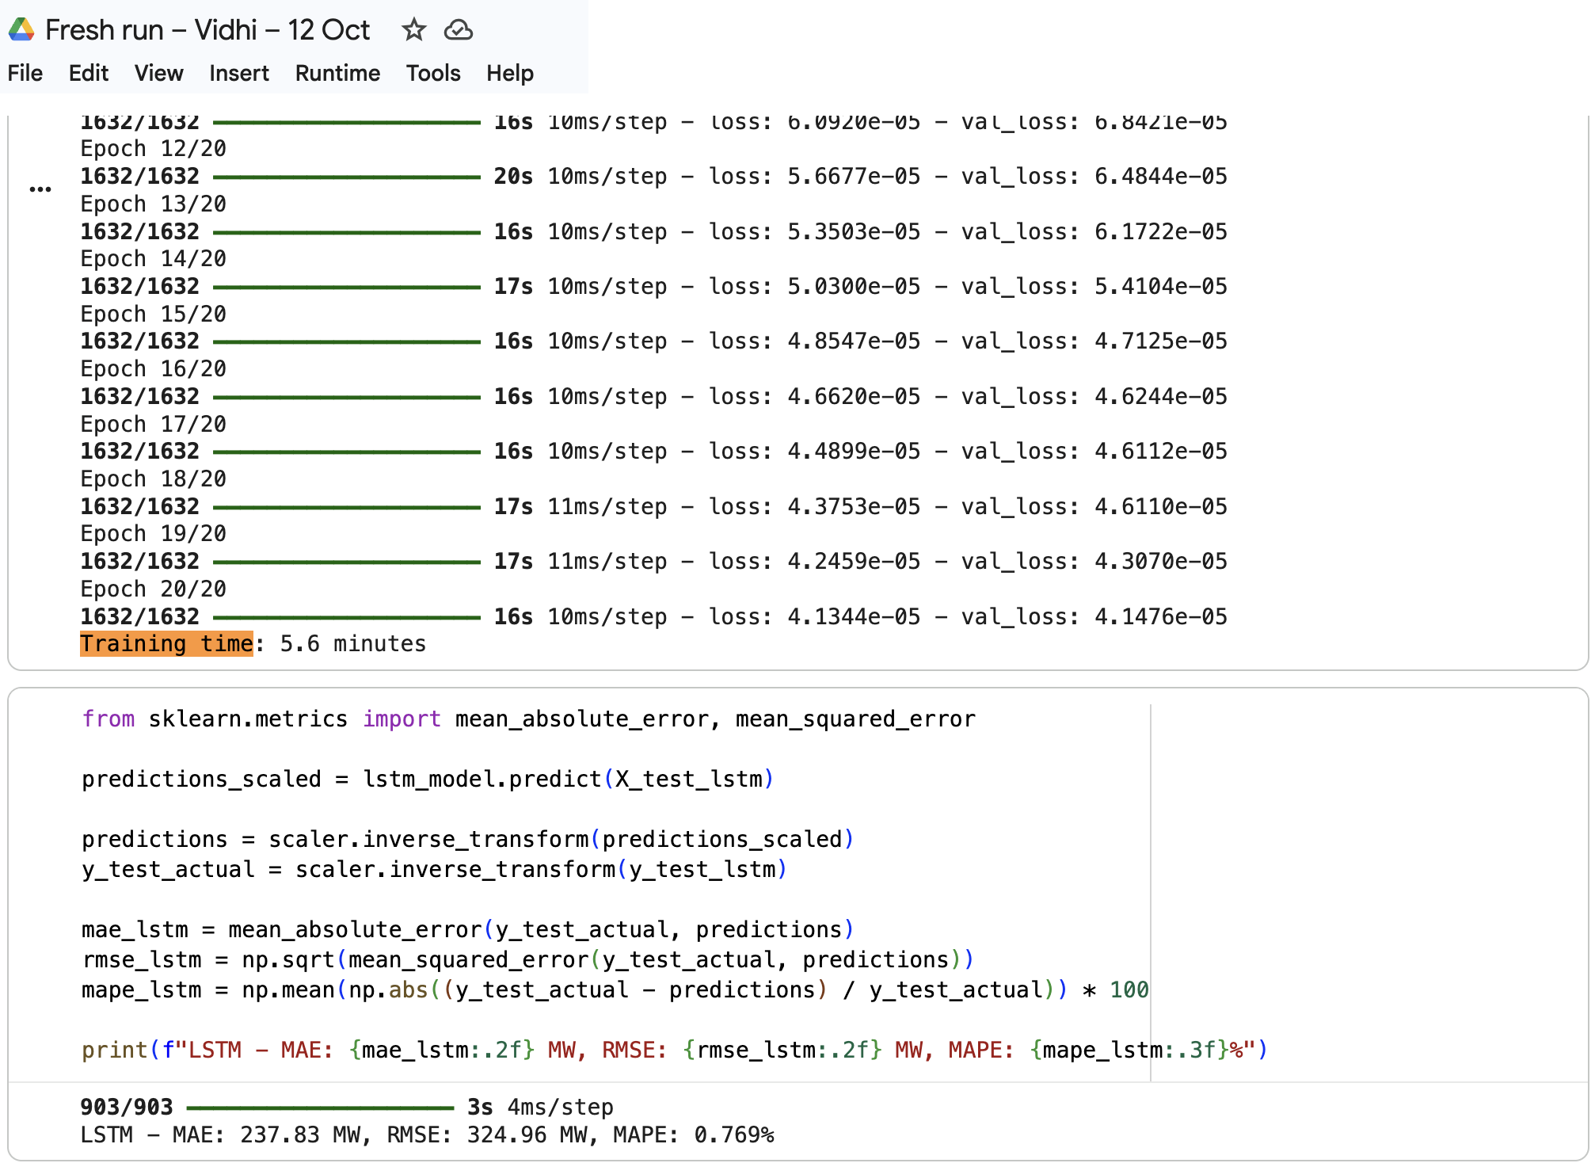  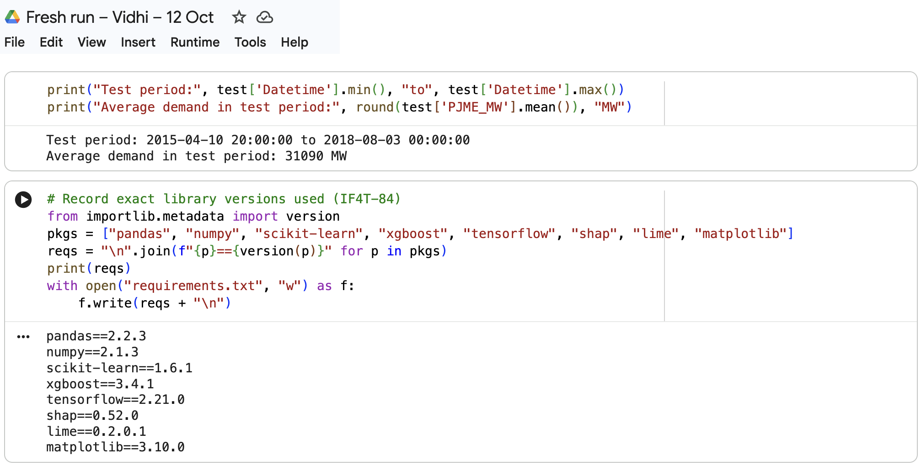 | 5.5hrs
Marwa Aldhafeeri | 1. Worked on Activity 1 licence research.  2. Collected licence screenshots and added official source URLs in Appendix – Licence Evidence.  3. Prepared the Dependencies and licences README section | T | Dependencies and licences – README draft:  Dependencies and licences.docx | 7hrs

Agreed actions for the coming week

Owner | Action to complete before next workshop | Due date
Yaqiao | Add the MIT LICENSE file to the GitHub repository;  Add the “Dependencies and licences” section to README | 14 Oct
Bhumika | Lag feature leakage spot-check (IF4T-82);  Error breakdown by season / weekday / peak and top-5 error days (IF4T-88), to complete the “When to be careful” section of the summary | 14 Oct
Vidhi | Usability test of the plain-English summary with a non-technical reader (IF4T-90); | 14 Oct
Marwa | Add the source link (URL) under each screenshot in the Appendix – Licence Evidence | 14 Oct
All | Review the presentation requirements released by the tutor and agree presentation roles | 15 Oct

Anything blocking the team, or any contribution imbalance the tutor should know about?

All four members attended the 8 October workshop. Vidhi and Marwa were briefed on project progress and assigned independent testing and documentation tasks with deadlines before 15 October, and written step-by-step instructions were shared in the group chat.

Their contributions are recorded from this week onwards.

The core model code and main report sections remain with Yaqiao and Bhumika to reduce risk before the final deadline.

Correction to Week 8 worklog. The results reported in Week 8 (LSTM MAE 217.78 MW, Hybrid 215.41 MW) came from a non-deterministic run. After enabling deterministic training, the final reproducible results are LSTM 237.83 MW and Hybrid 228.96 MW (MAPE 0.728%). All notebook documentation has been updated accordingly.

Appendix – Licence Evidence (Marwa)

1. pandas
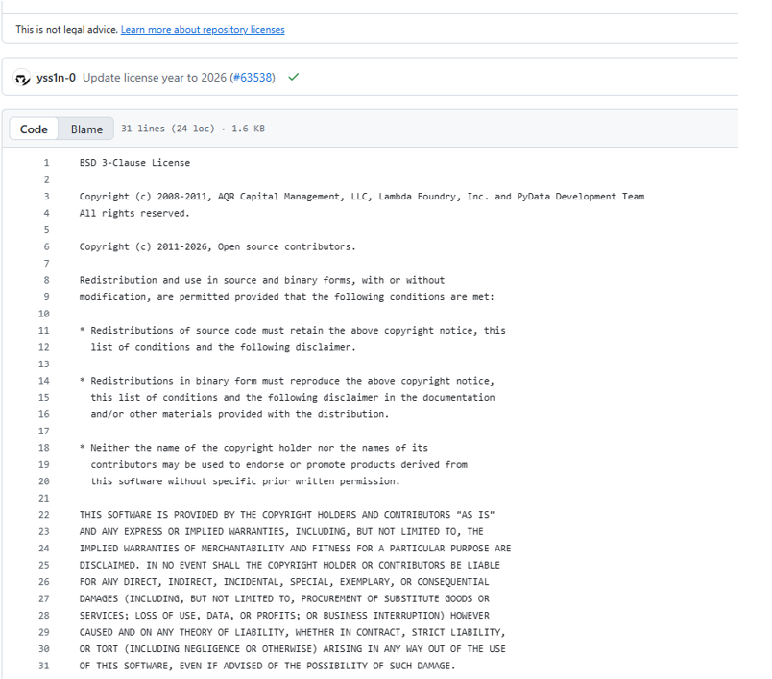Source: https://github.com/pandas-dev/pandas/blob/main/LICENSE

2. NumPy
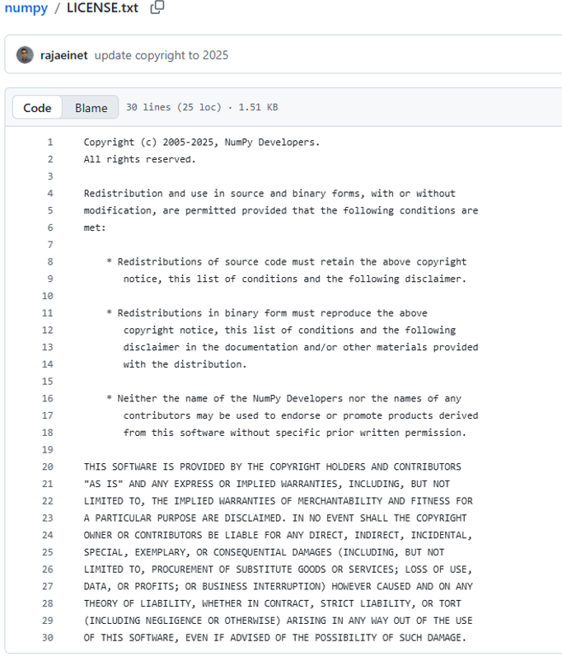
Source: https://github.com/numpy/numpy/blob/main/LICENSE.txt

3. scikit-learn
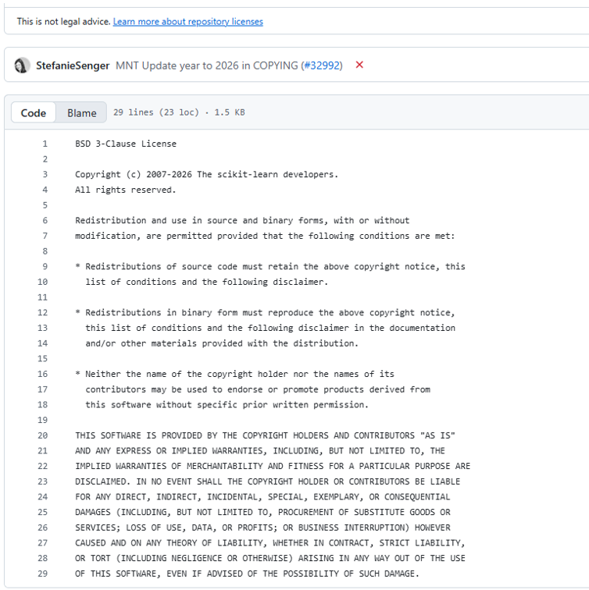Source: https://github.com/scikit-learn/scikit-learn/blob/main/COPYING

4. TensorFlow
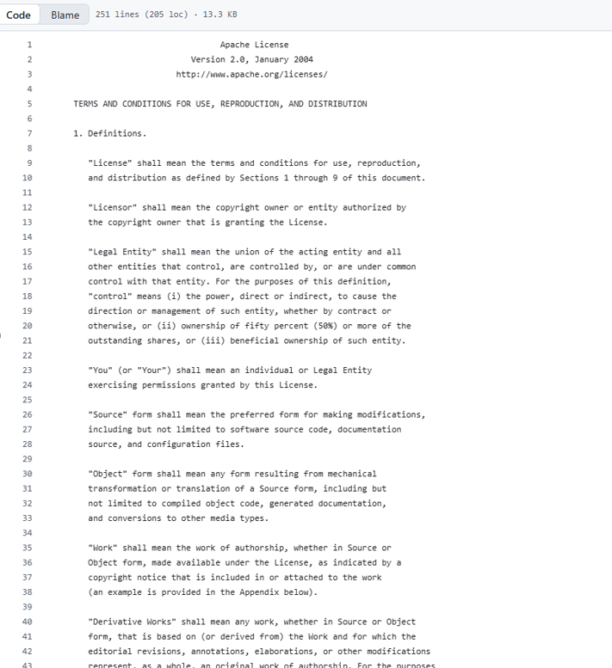

Source: https://github.com/tensorflow/tensorflow/blob/master/LICENSE

5. XGBoost
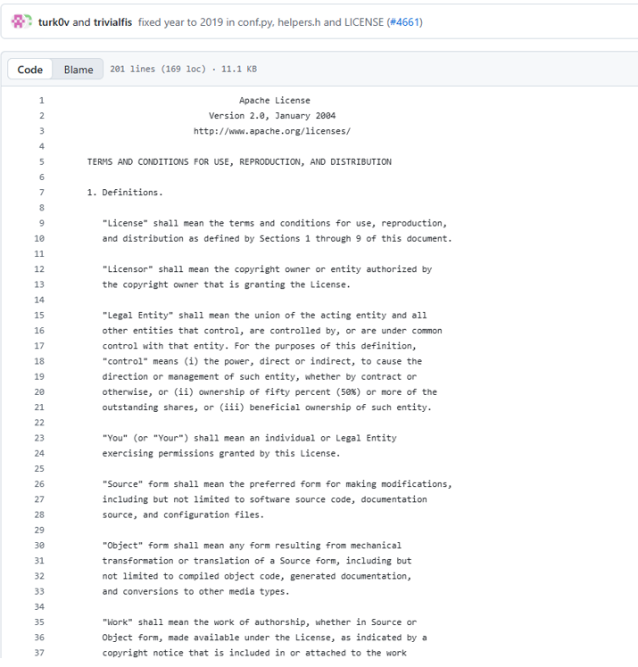
Source: https://github.com/dmlc/xgboost/blob/master/LICENSE

6. SHAP
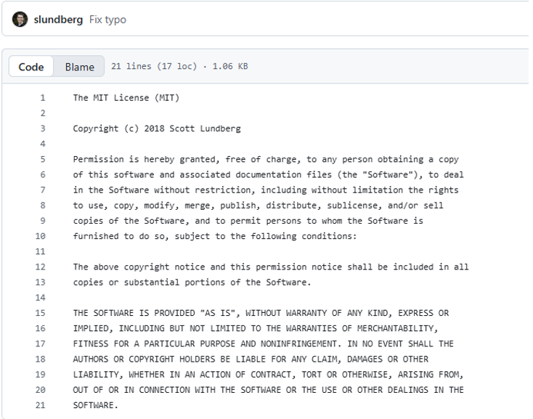Source: https://github.com/shap/shap/blob/master/LICENSE

7. LIME
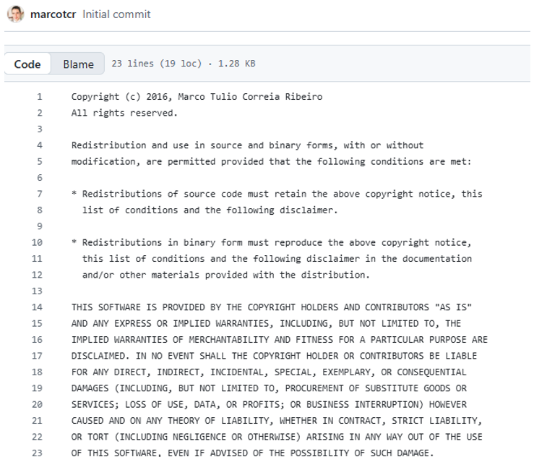Source: https://github.com/marcotcr/lime/blob/master/LICENSE

8. Matplotlib
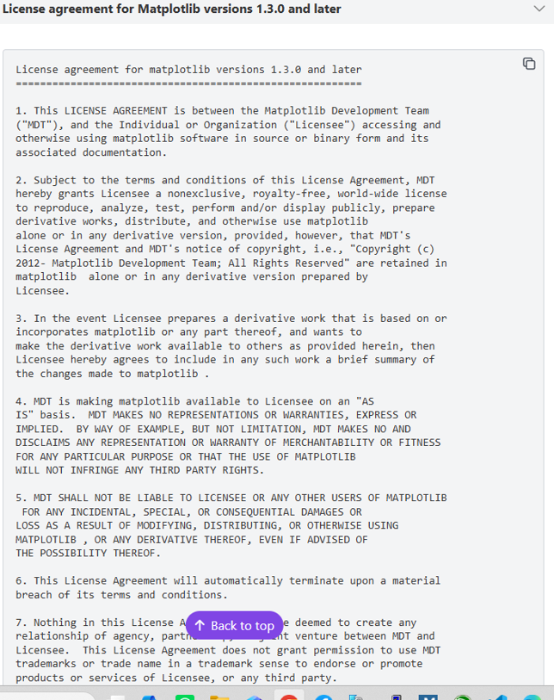
Source: https://matplotlib.org/stable/project/license.html

9. Creative Commons — CC0 1.0
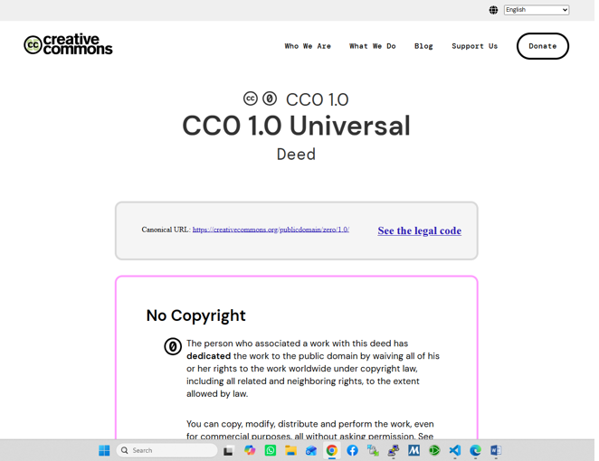Source: https://creativecommons.org/publicdomain/zero/1.0/

10. Kaggle PJM dataset — CC0: Public Domain

Source: https://www.kaggle.com/datasets/robikscube/hourly-energy-consumption

Appendix B – Licensing Assistant – comparison of MIT, Apache-2.0 and GPL-3.0 (Yaqiao)

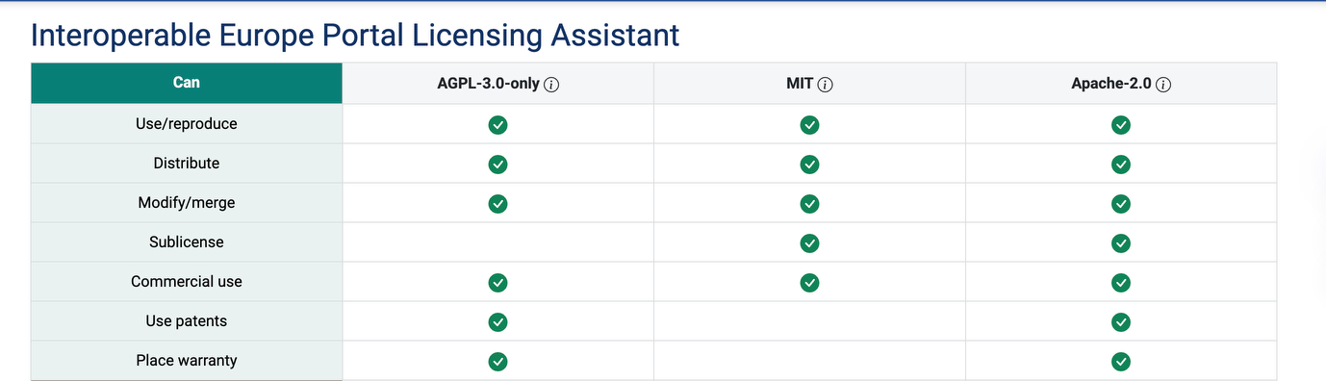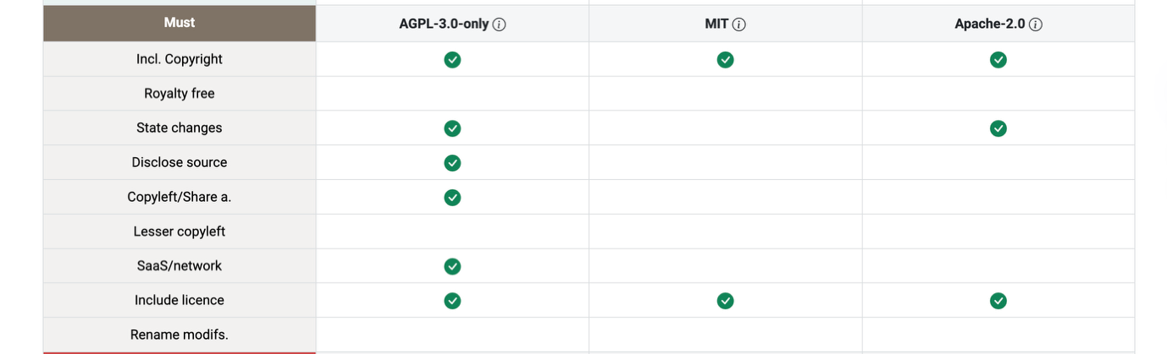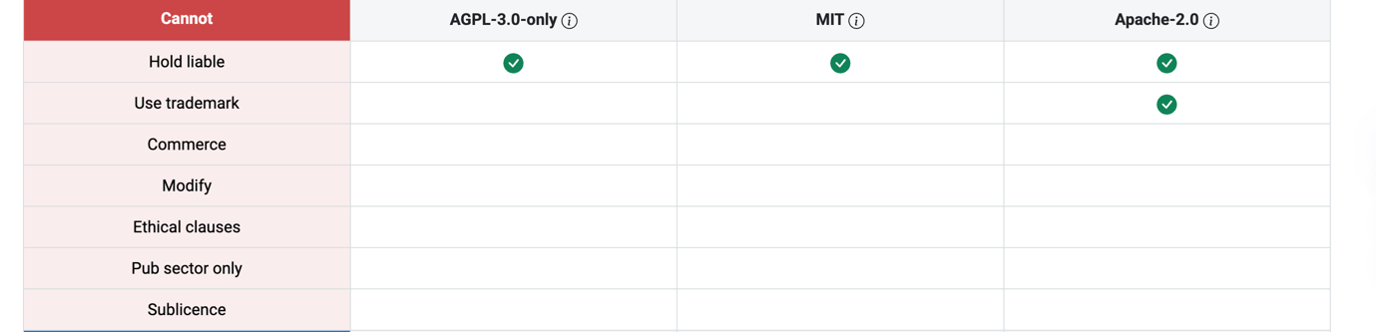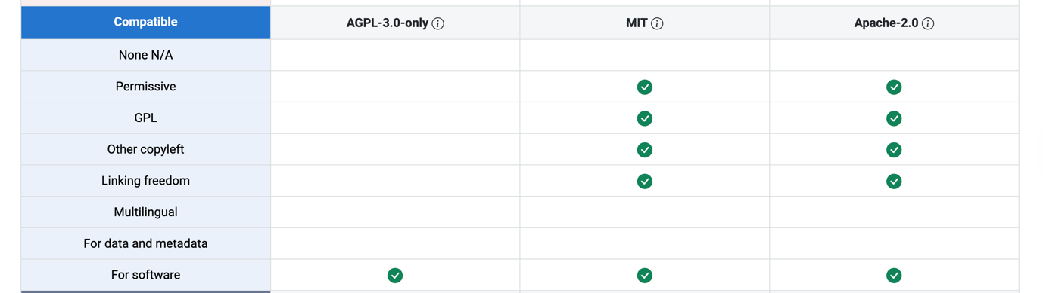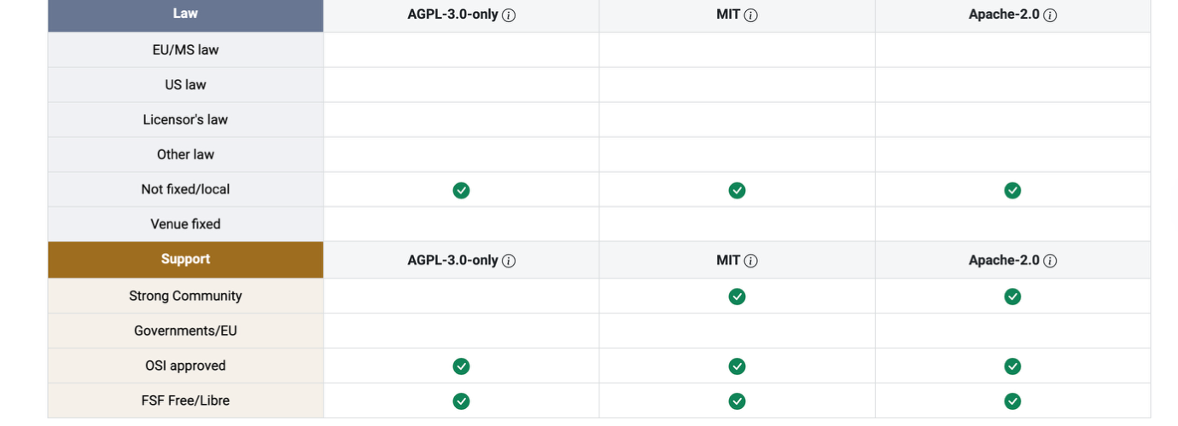
Link: https://interoperable-europe.ec.europa.eu/licence/compare/AGPL-3.0-only;MIT;Apache-2.0

Comparison generated with the EU Licensing Assistant (interoperable-europe.ec.europa.eu), accessed 12 October 2026. Apache-2.0 grants a patent licence and requires stating changes; GPL-3.0 requires disclosing source code and sharing derivatives under the same licence; MIT only requires keeping the copyright and licence notice.

